**18. Create a Storage service using any Public Cloud Service Provider (Azure/GCP/AWS) and check the public accessibility of the stored file to demonstrate Storage as a Service.**

**STEP1:**

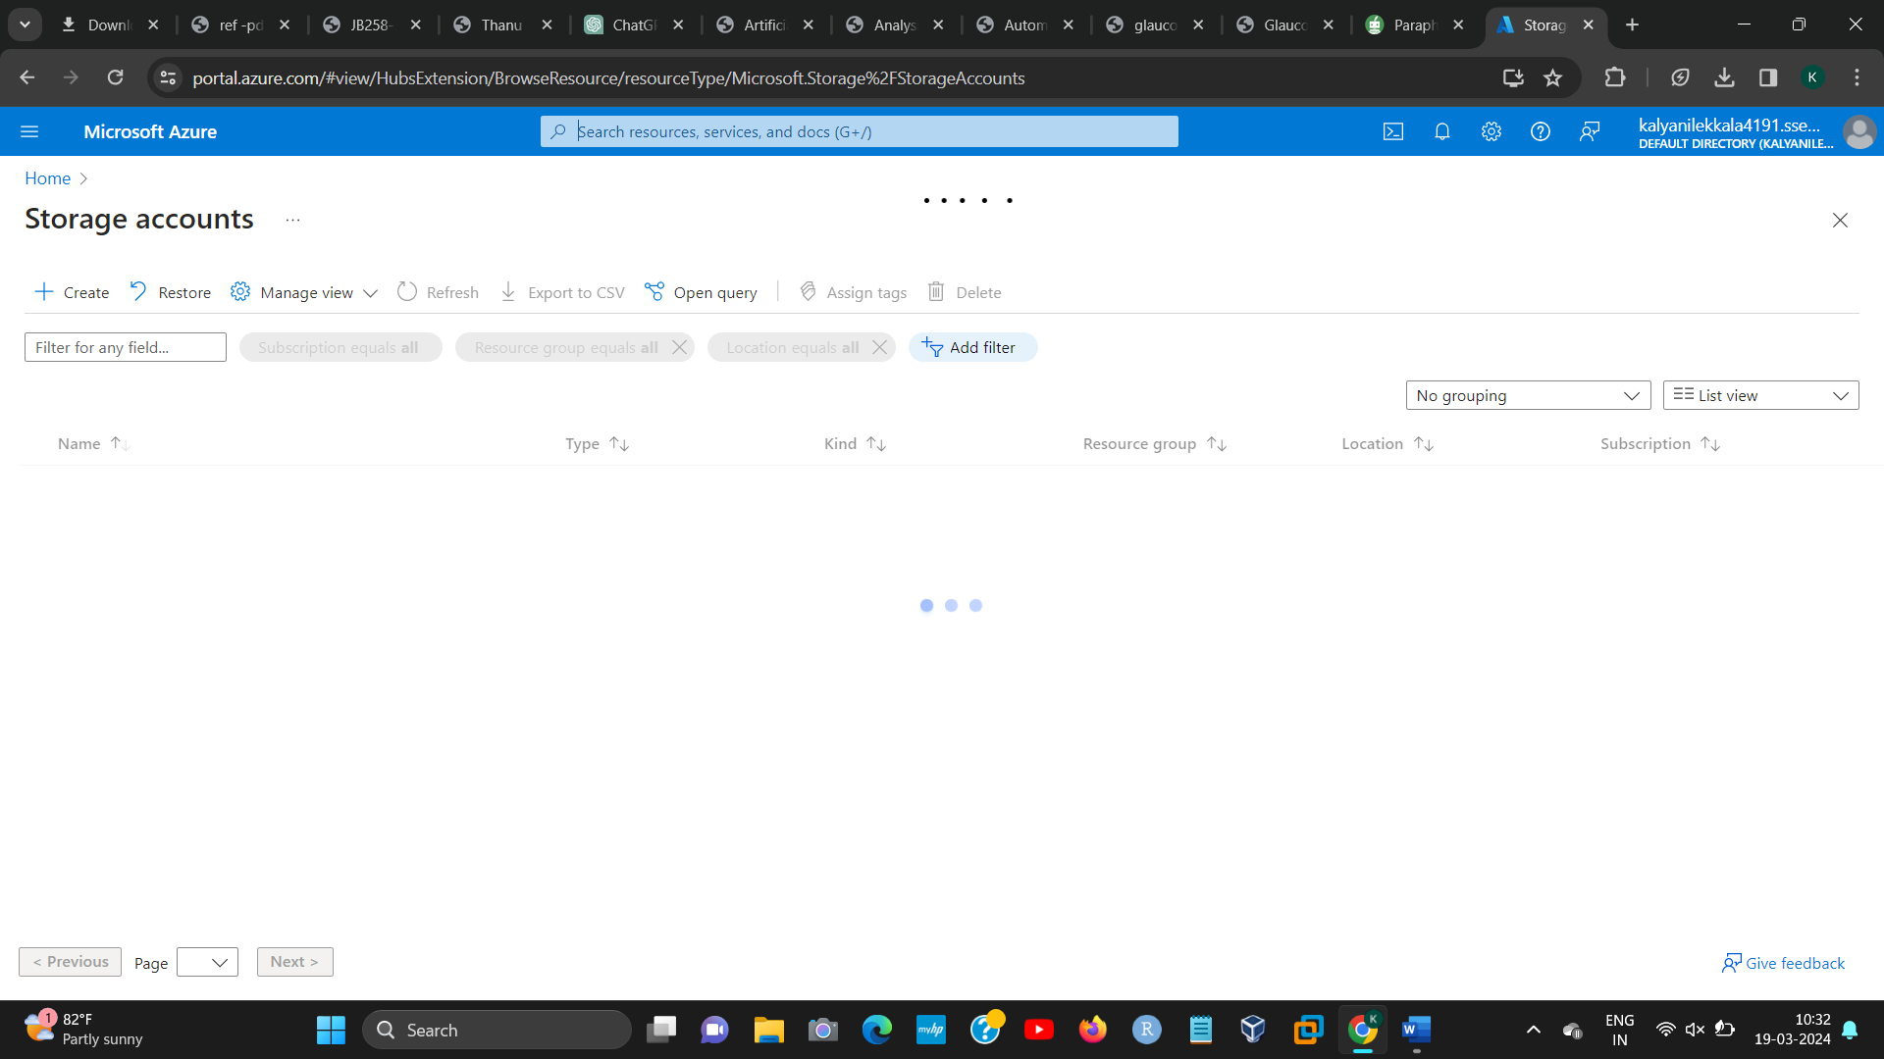

**STEP2:**

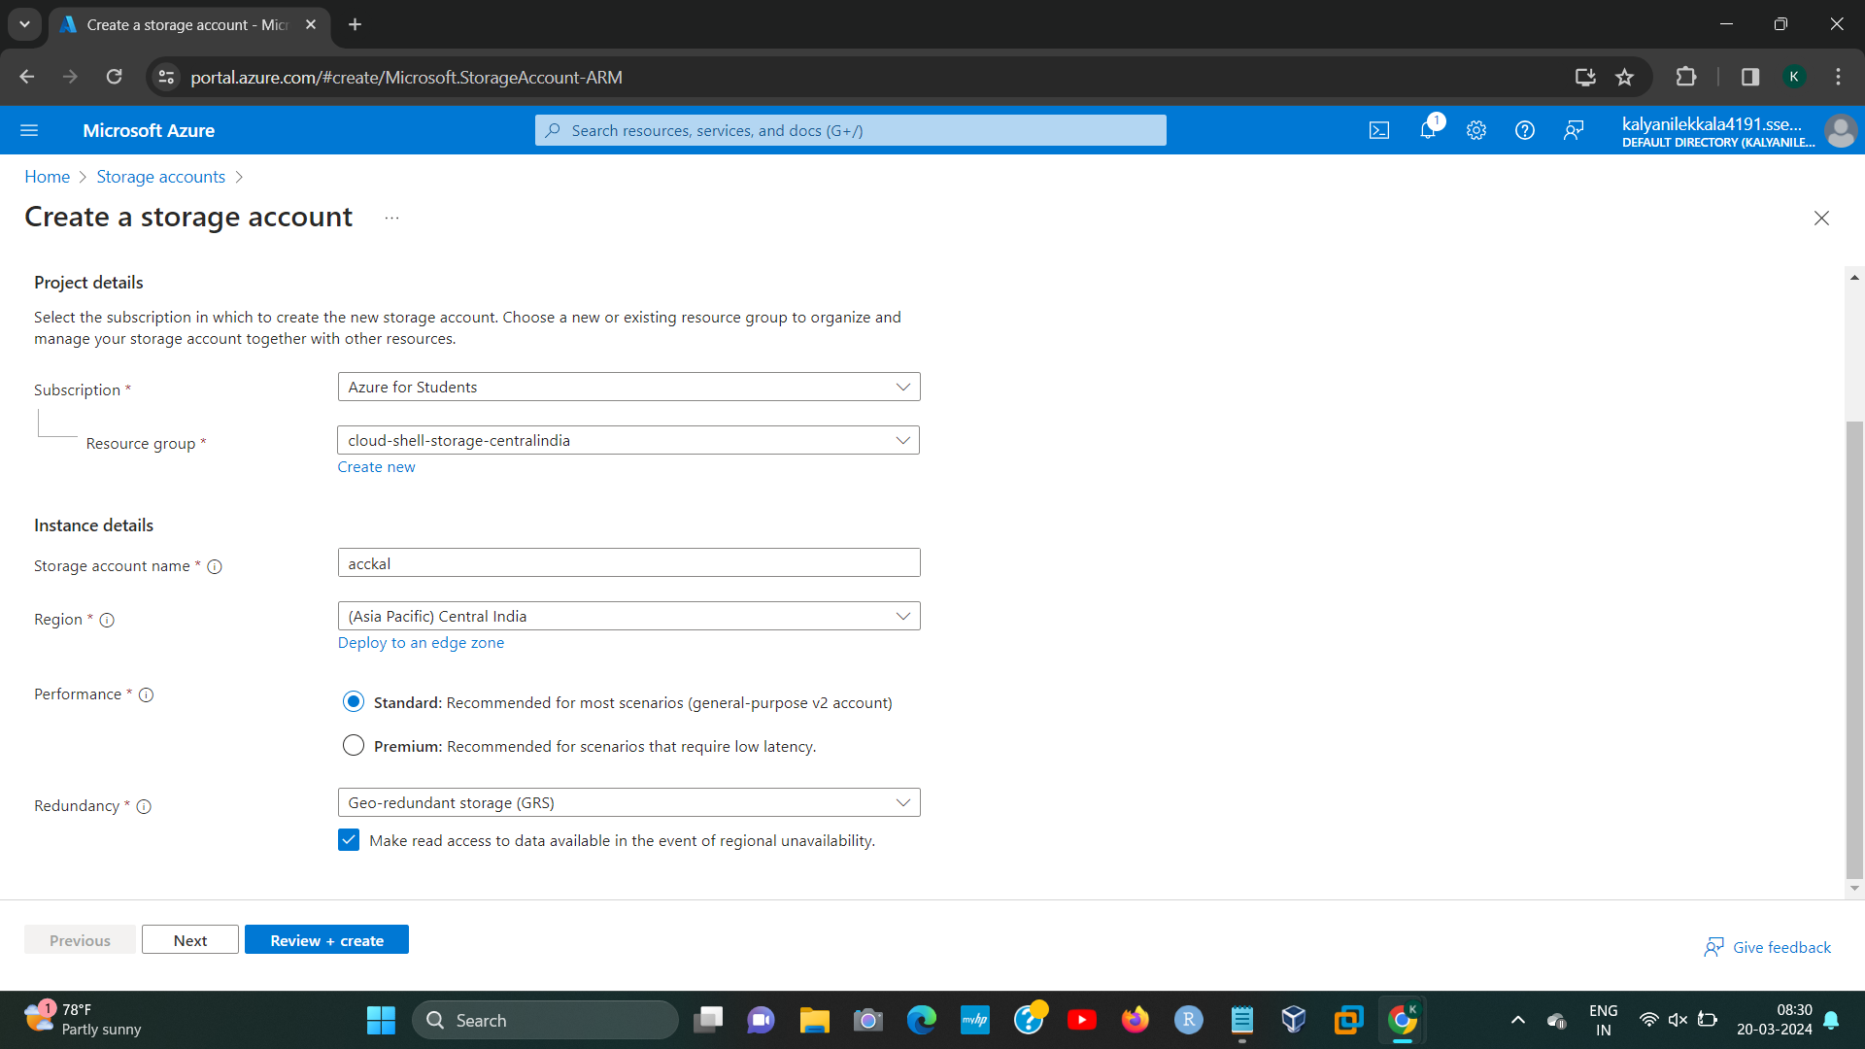**[1]**

**Step3:**

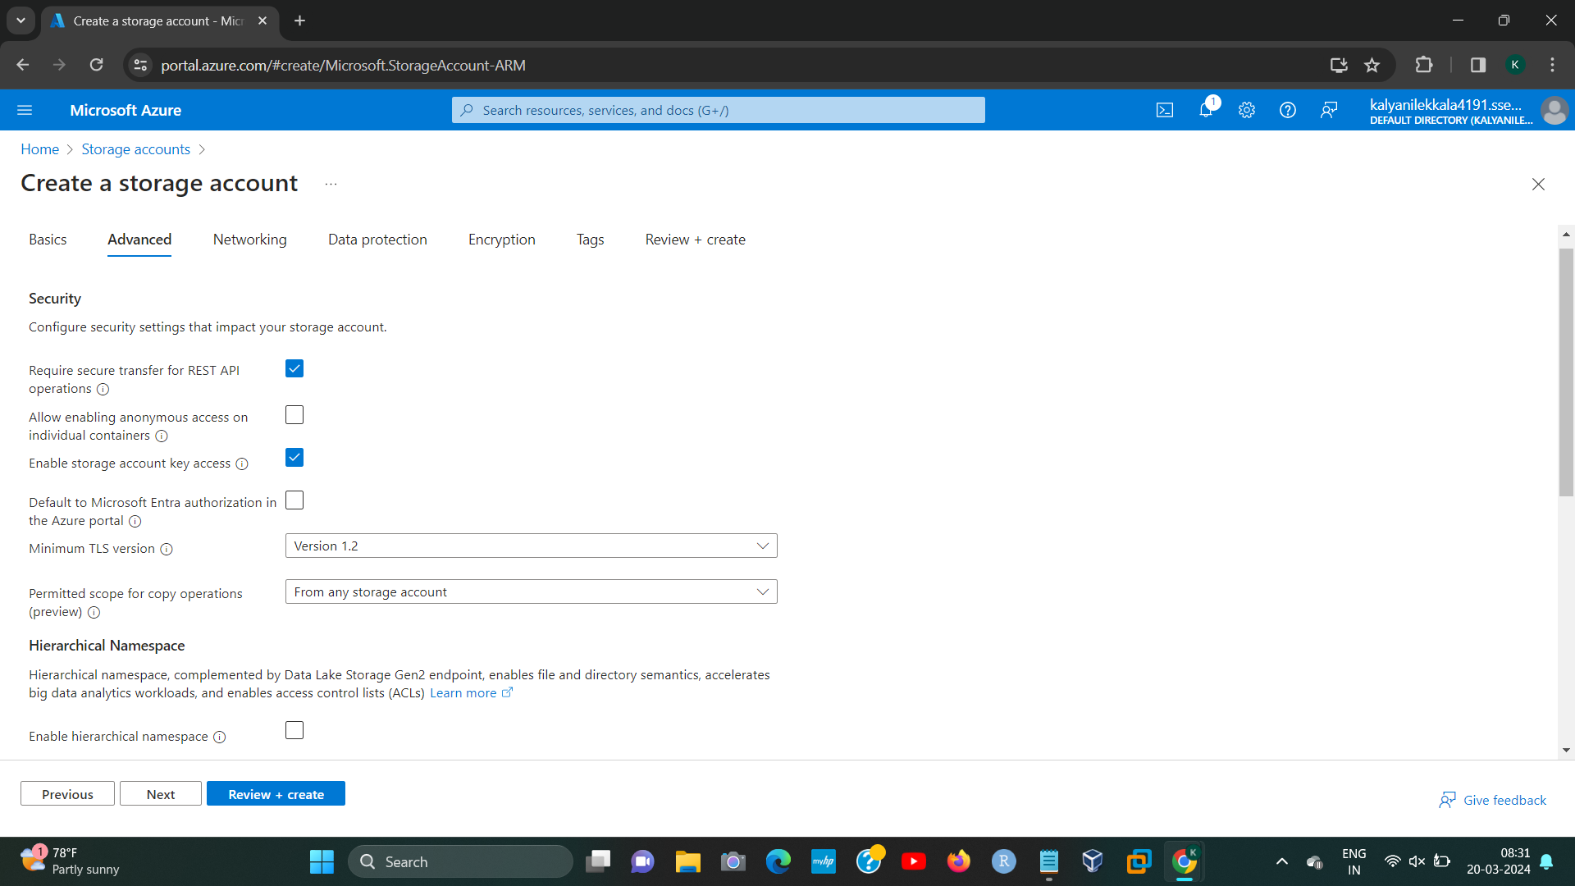

**Step4:**

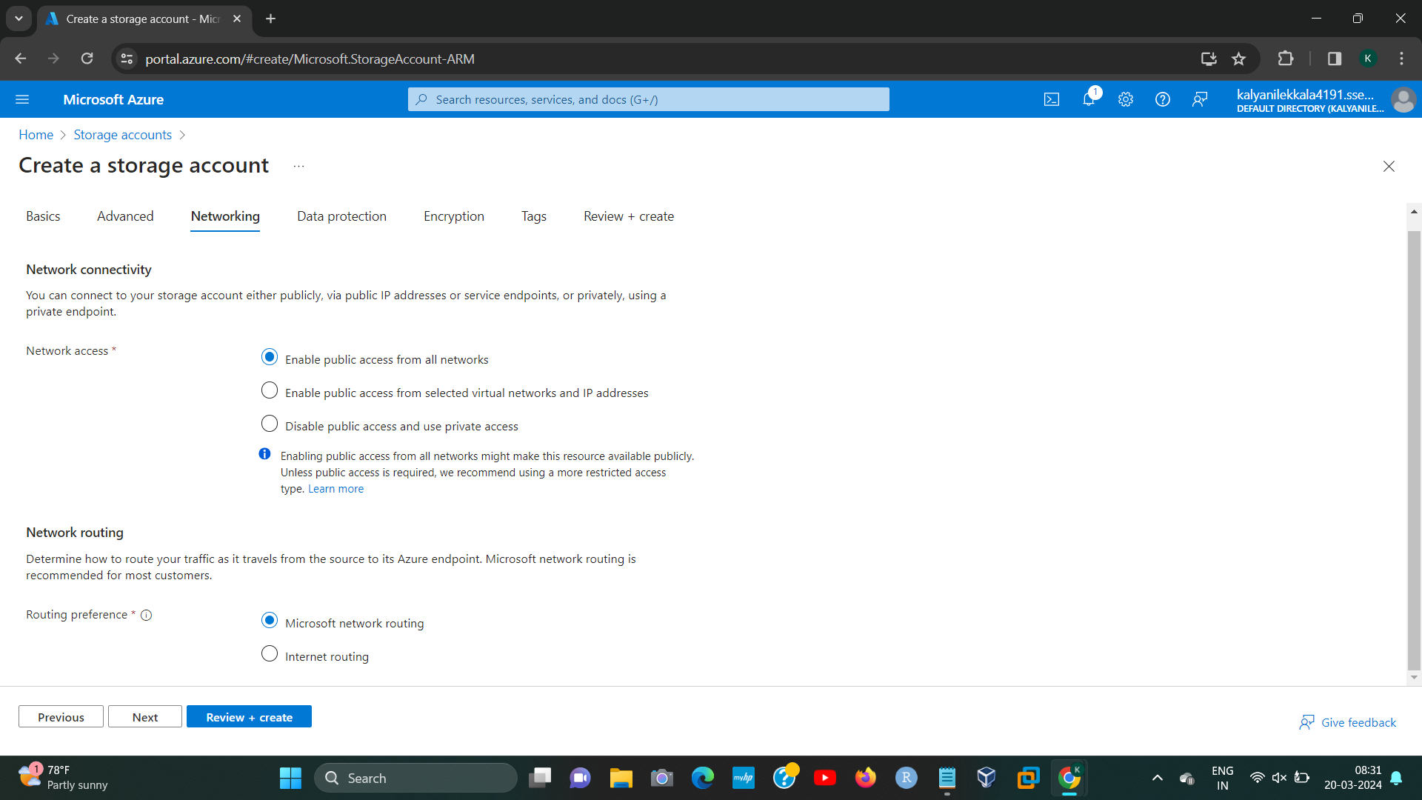**[2]**

**STEP5:**

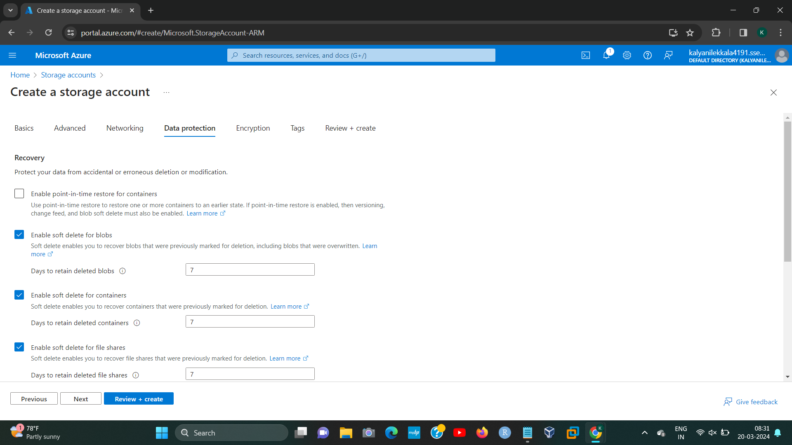

**STEP6:**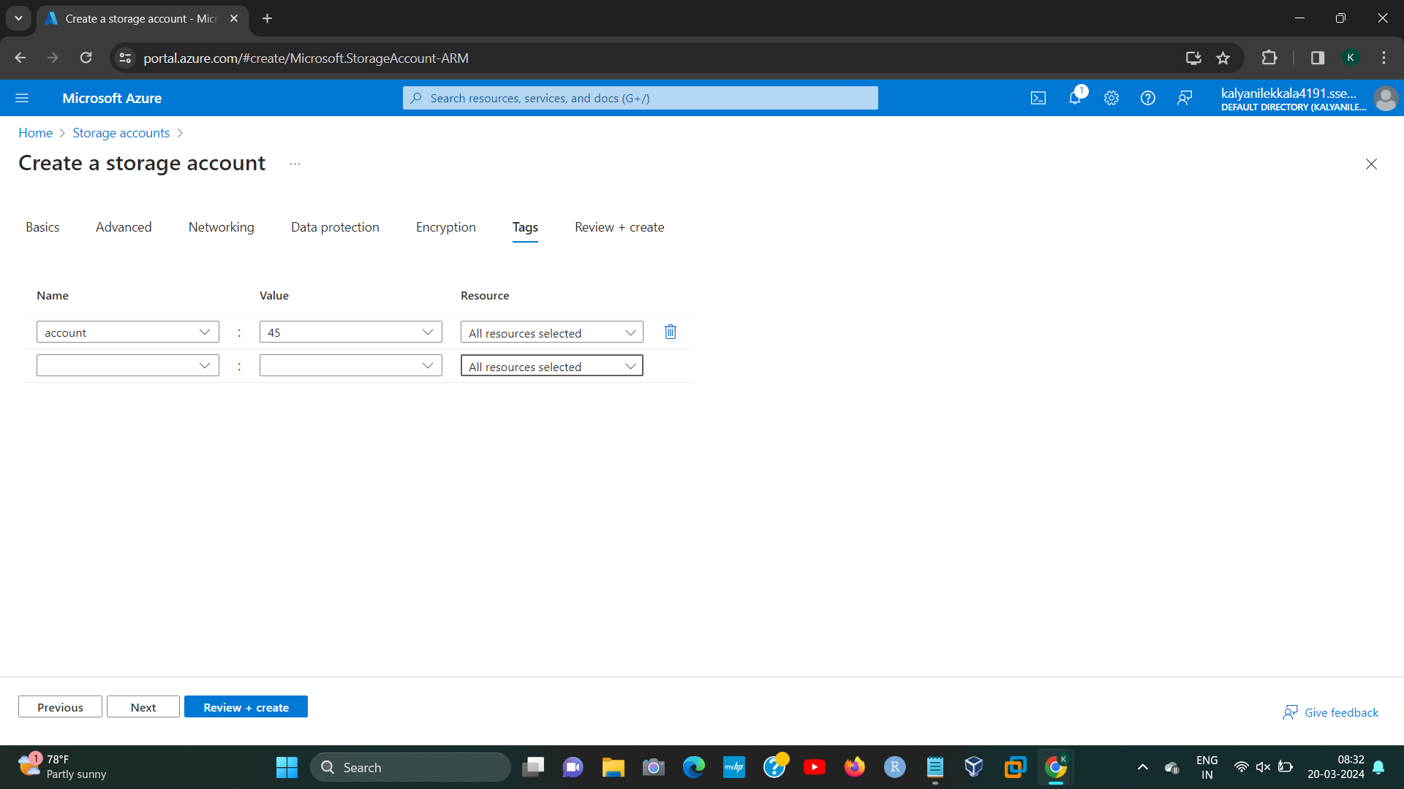

[3]

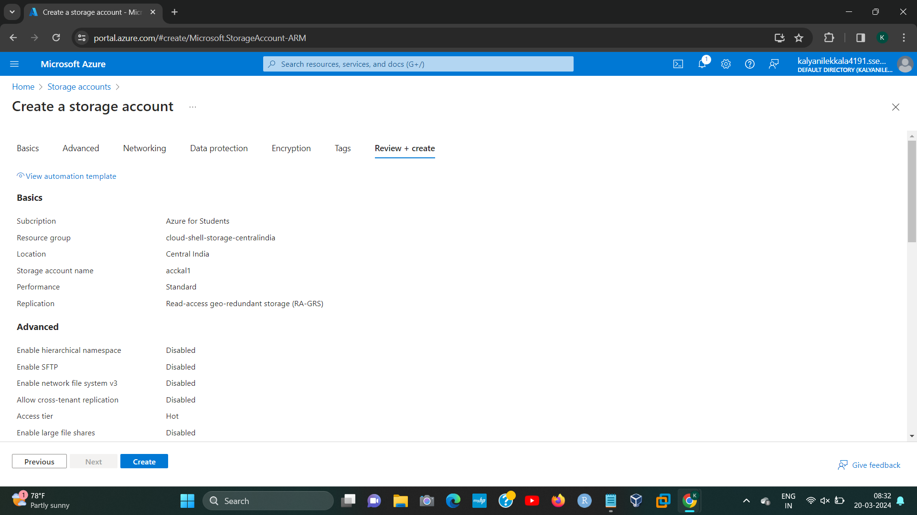

**STEP8;**

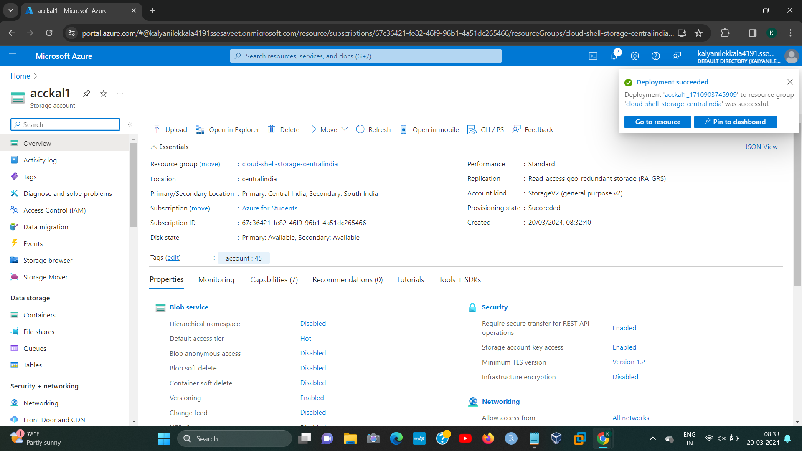**[4]**

**STEP9:**

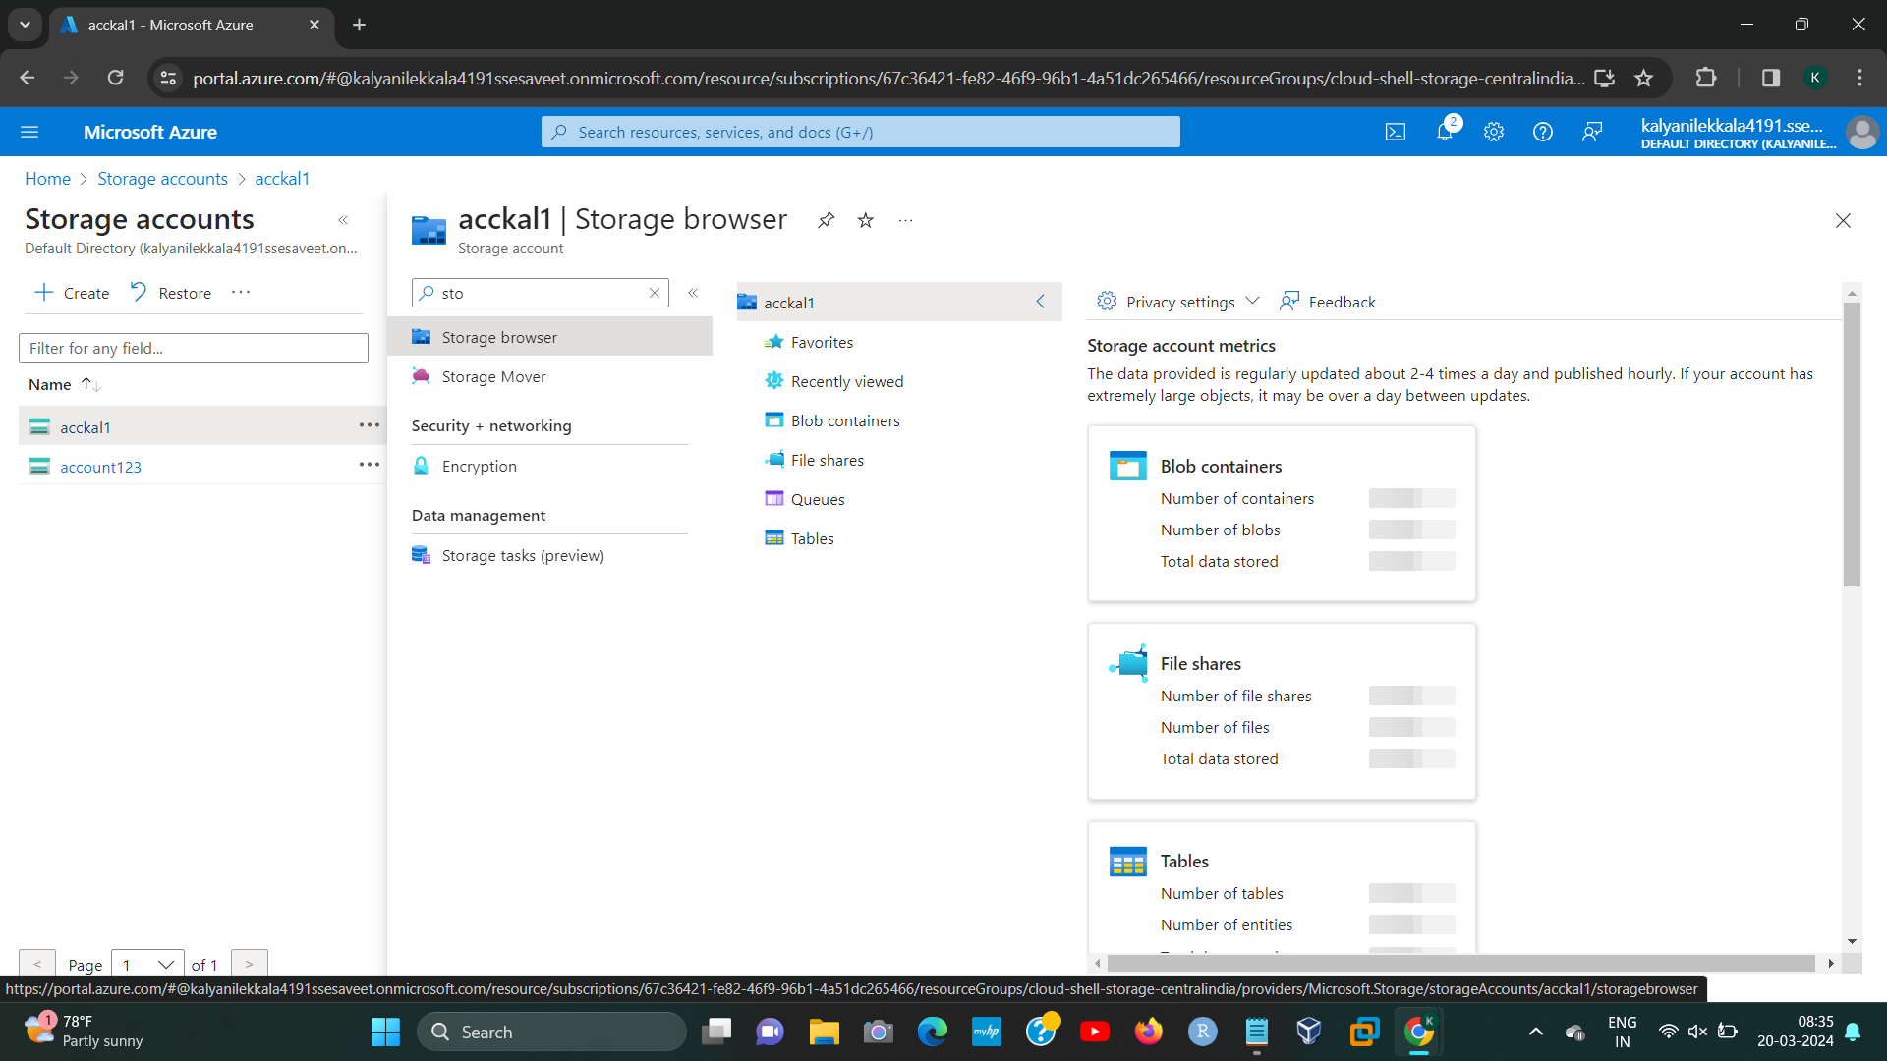

**STEP10:**

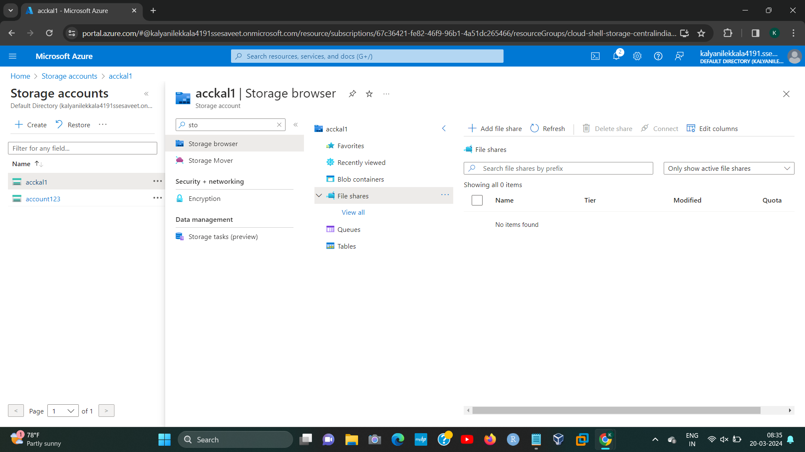

192224191 L.KALYANI

**STEP11:**

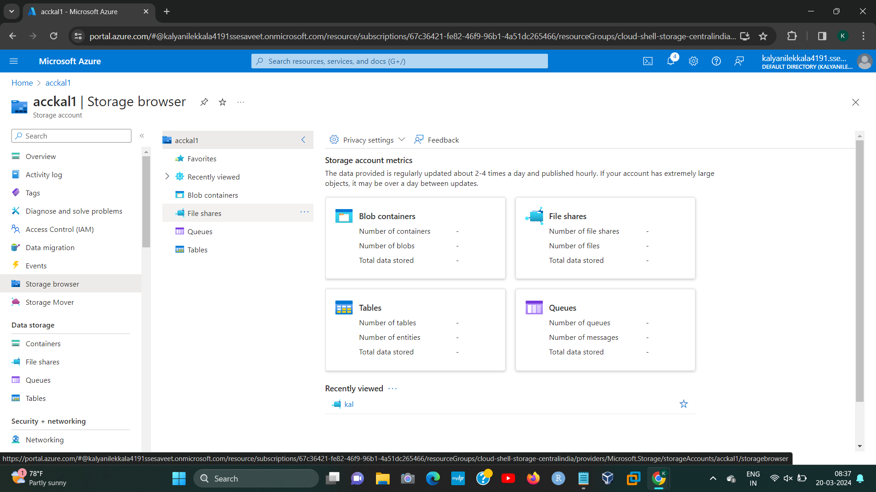

**STEP12:**

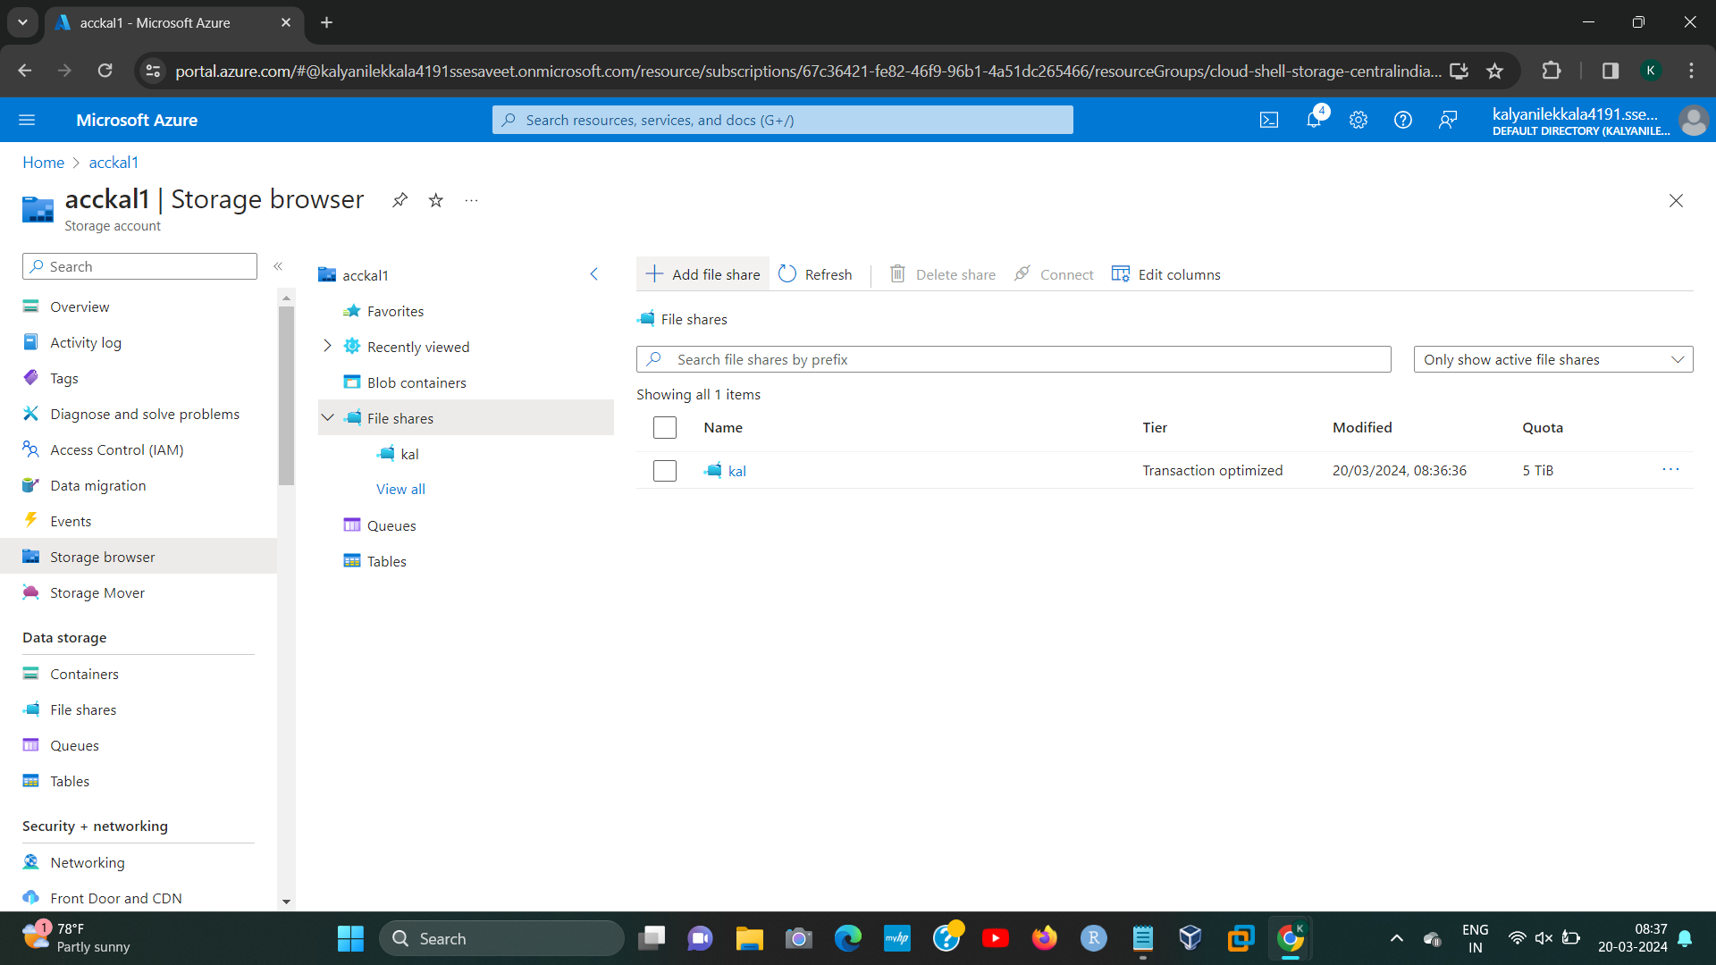

192224191 L.KALYANI

**STEP13:  
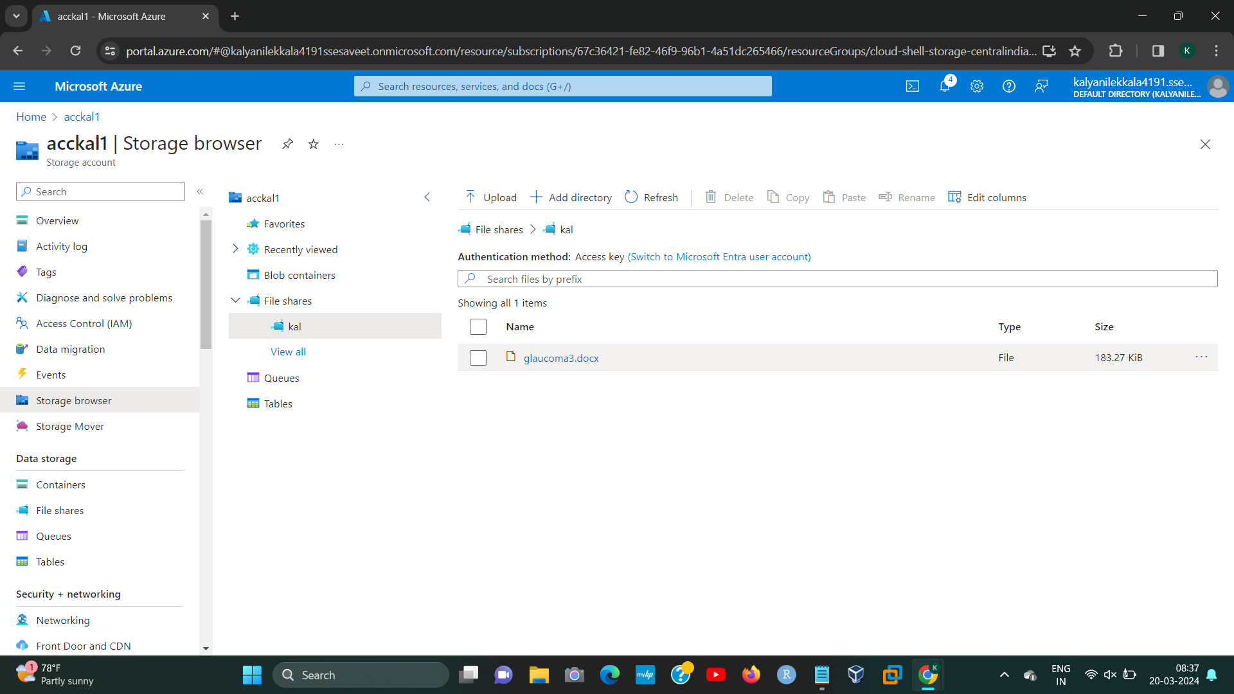**

192224191 L.KALYANI

1. 192224191 L.KALYANI
2. 192224191 L.KALYANI
3. 192224191 L.KALYANI
4. 192224191 L.KALYANI